EMERGENCY OPERATIONS AND ESCALATIONS

Version 2023

Review & update

Contents

2. Document history 3

3. Introduction 5

4. Scope 5

5. EOP Performance Indicators 5

6. Responsibilities 5

Viking Medical Solutions 5

Employee 5

7. EOP 1 Airway Management 6

General Principles 6

Escalation 6

Essential Airway Management 6

Advanced Airway Management – Supraglottic Devices 6

Advanced Airway Management – Endotracheal Intubation 7

Paramedic Escalation Process 8

Drug facilitated maintenance of an advanced airway 8

Needle and Surgical Cricothyroidotomy 8

Needle Thoracostomy (Chest Decompression) 9

8. EOP2 Cardiac Arrest Management 9

BLS Algorithm 9

ALS Algorithm 10

Escalation 10

9. EOP3 Choking Management 11

Escalation 12

10. EOP4 Stroke Management – EOP Performance Indicator no1 12

Escalation 12

11. EOP5 Seizure Management 12

Escalation 12

12. EOP6 Severe allergic response & anaphylaxis management 13

Escalation 14

13. EOP7 Chest Pain Management 14

Escalation 14

14. EOP8 Scene Safety & Primary Survey 14

Escalation 14

15. EOP9 Defibrillation Management 14

Escalation 15

16. EOP10 Do Not Attempt Resuscitation (DNAR) & Advanced Directive of Refusal of Treatment (ADRT) 15

Escalation 15

17. EOP11 Palliative Care 15

Escalation 16

18. EOP12 Prevention Management of Violence, Aggression & Restraint 16

Why do patients become 'challenging'? 16

Their behaviour may take the form of: 16

Identifying the problem 17

Is it the patient? 17

Is it a lack of resources? 17

Is it the doctor? 17

Assessing the risk 17

Identify high-risk situations 17

Defusing a violent situation 17

What can you do? 17

Escalation 18

19. EOP13 Mental Health Risk Assessment, capacity & Conveyance 18

The test of capacity 19

The Functional Test 19

Escalation 20

20. EOP14 Management of potential crime scene and or victims of crime 20

21. EOP15 Management of Clinical Handover 20

Escalation 21

22. EOP16 Management of the absconding patient 21

Escalation 21

23. EOP17 Management of obstetric emergencies 21

Escalation 21

24. Review 22

25. Appendix 1 - Emergency Arrangements 22

26. Appendix 2 - Abbreviated Mental Test Score (AMTS) 22

# Document history

|  |  |  |
| --- | --- | --- |
| Date | Manager | Comments |
| 11/08/2019 | Carl Thomson | Published document |
| 01/02/2020 | Reuben Dale | Updated styling and grammar |
| April 2020 | Carl Thomson | Updates to EOP 9 (defibrillation), EOP13 (MH) and additions of EOP 15 (clinical handover), EOP16 (absconding Pt) and EOP 17 (obstetric emergencies) |
| Feb 2023 | Carl Thomson | Review & update |

# Introduction

Viking Medical Solutions (VMS) has a set of Emergency Operations Procedures (EOPs) to assist its organisation & clinical staff to remain in the scope of their own practice, to assist with management & treatment of the most common encountered conditions and to identify specific skill procedural techniques for intervention.

# Scope

It remains vitally important that all VMS staff only perform skills & duties in line with their clinical scope of practice. This is actually easier for the registered healthcare professional who has specific regulatory body requirements and competencies that are clearly defined. This policy will reinforce those and provide company guidance to non-registered clinical staff.

This policy will include skill procedural techniques and the most common emergency conditions encountered. VMS will draw upon legislation & guidance from the following:

* National Institute for Clinical Excellence (NICE)
* Joint Royal College Ambulance Liaison Committee (JRCALC)
* Resuscitation Council (UK)
* NHS England – New Ambulance Standards

# EOP Performance Indicators

VMS for a period of 12 months will audit 2 EOPs under EOP performance indicators as part of company quality assurance. Similar to that of NHS Clinical Performance Indicators (CPIs). The clinical director via Patient Record forms will audit 2 x chosen EOPs as stated during QA meetings.

# Responsibilities

## Viking Medical Solutions

It will remain the medical director’s responsibility to ensure that all clinical staff are familiar with this policy, where it can be found, that it is included into company induction and that it is subjected to the usual policy review process as declared in the VMS Audit & Review of Policies Policy. It will be the Operations managers responsibility that a copy can be found on all operational vehicular resources.

## Employee

It will be the employee’s responsibility to remain and operate only at the clinical level of their grade, to be familiar with this VMS policy and other clinical policies such as defibrillation, clinical supervision, consent and capacity etc.

In the event of a situation that falls outside of scope of practice or knowledge the following measures can be considered:

* To request a VMS Paramedic to scene
* To call the VMS emergency advice line in accordance with the emergency arrangement section of the Clinical Supervision Policy (appendix 1)
* To call 999 and ask for the relevant emergency service

# EOP 1 Airway Management

## General Principles

Assessment of airway patency, and potential threats to patency, must form part of the initial examination of all patients

Where active airway management is required, a stepwise approach incorporating essential airway manoeuvres progressing to more advanced techniques where clinically indicated should be employed.

Staff must act within their scope of practice at all times and must not attempt to perform techniques for which they have not received approved training.

Students on an approved training programme may assist with or undertake airway management skills commensurate with their level of training. This is at the discretion of the lead clinician, who shall at all times remain directly responsible for the care of the patient and must provide continuous supervision to the student / non-registered staff throughout the procedure.

In cases where difficulties are encountered in achieving adequate airway management, early consideration should be given to accessing senior support, either by mobilising additional senior clinical resources to the scene or initiating early transportation to an appropriate hospital. Staff must not unduly prolong on-scene time where an unmanageable airway is identified.

## Escalation

In all circumstance of airway difficulty – default 999 and then call/radio VMS online clinical for support & advice.

Paramedic to follow escalation diagram below

## Essential Airway Management

All clinical staff will undergo training in essential airway management.

Essential airway management manoeuvres must be undertaken in all patients requiring airway intervention including the use of simple airway adjuncts where appropriate prior to escalating to advanced airway management techniques.

## Advanced Airway Management – Supraglottic Devices

All paramedics will undergo training in the use of supraglottic devices in adults, children and infants.

EMT and EAC staff who have undergone Trust-approved training may utilise supraglottic airways exclusively in adult patients.

Prior to use of a supraglottic airway, the necessary equipment should be prepared

Immediately prior to insertion, the operator must instrument the airway using an appropriately sized laryngoscope to perform a visual check for any obstruction. Any obstruction must be removed prior to insertion of a supraglottic device.

End Tidal CO2 incorporating waveform capnography must be applied immediately post insertion of an SGA and maintained throughout the time that the VMS clinician is responsible for the patient. A A recorded capnography reading must be applied to all PRFs.

Insertion of an orogastric or suctioning tube via a supraglottic device is restricted to paramedics who have undergone appropriate training.

## Advanced Airway Management – Endotracheal Intubation

All paramedics and EMT/EAC staff will receive training to enable them to assist with the procedure of endotracheal intubation.

Paramedics who obtained professional registration after the 1st June 2010 are not permitted to perform endotracheal intubation unless evidence can be provided of competency.

Paramedics previously trained in endotracheal intubation prior to 1st June 2010 may continue to practice the technique subject to those stipulated by the relevant professional and regulatory bodies.

Staff not previously authorised to perform endotracheal intubation may undergo VMS approved training to undertake endotracheal intubation and will be authorised to perform the procedure upon completion of the approved development programme.

Prior to an endotracheal intubation attempt, the necessary equipment should be prepared to facilitate safe and efficient tracheal intubation.

The intubator should be assisted by a second clinician who is familiar with the technique and able to act in the capacity of ‘skilled assistant’.

A bougie must be used to facilitate endotracheal intubation, except in cases where this would impede the attempt (e.g. excessive flexibility due to heat).

End tidal CO2 incorporating waveform capnography must be applied immediately post intubation and maintained throughout the time that the VMS clinician is responsible for the patient. A capnography reading must be recorded of the PRF.

The absence of a clear box-shaped waveform capnograph trace post intubation must prompt immediate reassessment of the airway with rapid extubation and ventilation via essential airway manoeuvres if required.

Any actual or potential unrecognised oesophageal intubation must be immediately reported as an incident via the company incident reporting system. Any member of staff suspected of performing unrecognised oesopheageal intubation will have the skill of endotracheal intubation formally rescinded by the Medical Director until supportive training measure are in place and competency redeemed.

Default 999 and then call/radio VMS online clinical

## Paramedic Escalation Process

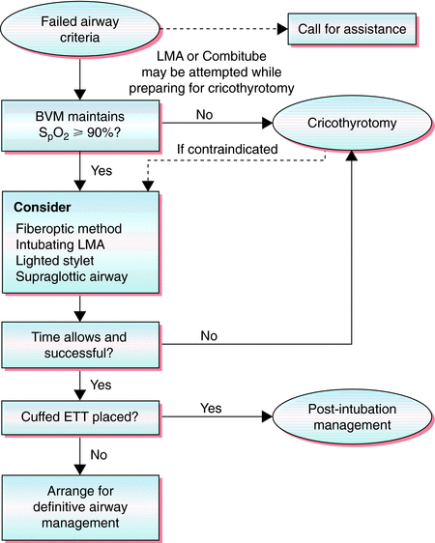

## Drug facilitated maintenance of an advanced airway

The use of pharmacological agents including sedatives and/or analgesics to facilitate tolerance of an advanced airway is restricted to suitably trained and experienced Doctors employed by the VMS and whom are licensed to use said pharmacological agents.

No clinical grade below that of doctor will perform Drug facilitated maintenance of an advanced airway.

## Needle and Surgical Cricothyroidotomy

All paramedics will have received training in, and be authorised to perform the procedure of needle cricothyroidotomy in patients.

The procedure of surgical cricothyroidotomy is restricted exclusively to Advanced Paramedic Practitioners (Critical Care) and Doctors employed by the VMS.

The sole indication for cricothyroidotomy is the true ‘cannot intubate, cannot oxygenate’ airway scenario where all other techniques have proven inadequate.

## Needle Thoracostomy (Chest Decompression)

All paramedics will have received training in and be authorised to perform the procedure of needle chest decompression.

The procedure of needle chest decompression is restricted exclusively Paramedic and those registered professionals who can evidence the required training

The sole indication for needle chest decompression is true ‘lung collapse’ identified by paradoxical chest movement, hyper-resonance of effected lung, tracheal deviation accompanied with difficulty in breathing and significant reduction in SPo2.

# EOP2 Cardiac Arrest Management

All VMS resuscitation attempts will be in line with guidelines set by the Resuscitation Council (UK)

All unregistered clinical staff & registered staff who are not Advanced Life Support (ALS) trained will follow the Basic Life Support (BLS) algorithm and all registered staff with appropriate ALS training will follow the Advanced Life Support (ALS) algorithm

## BLS Algorithm

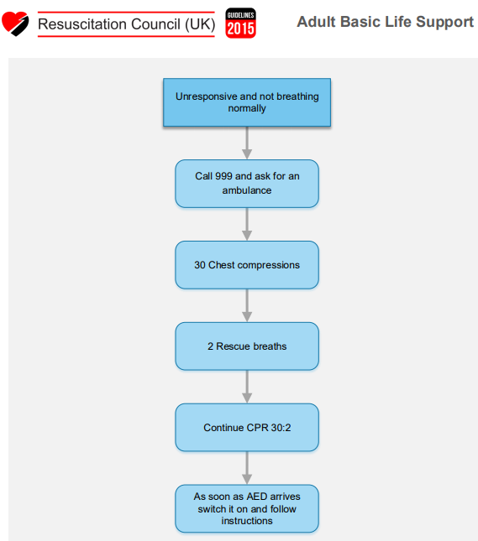

## ALS Algorithm

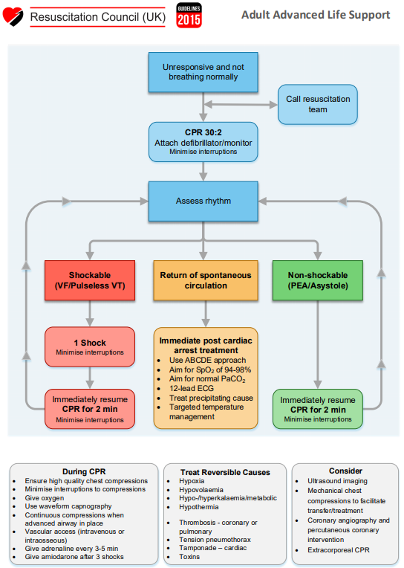

## Escalation

In all circumstances where there is a cardiac arrest regardless of clinical level 999 must be called and clinical level algorithm followed.

Resuscitation is to continue in all circumstance until a registered professional declares “Recognition of Life Extinct” (ROLE). This can be a VMS registered HCP or that from another provider eg. Paramedic from an NHS Ambulance trust – in this circumstance Identification requires checking and recording.

Additionally, the following must happen:

* Police attendance requested
* VMS director informed
* Incident report completed
* CQC informed as per Reporting of Significant Incident Policy

# EOP3 Choking Management

All grades of clinician are to follow the Resuscitation Council Guidelines for a choking event

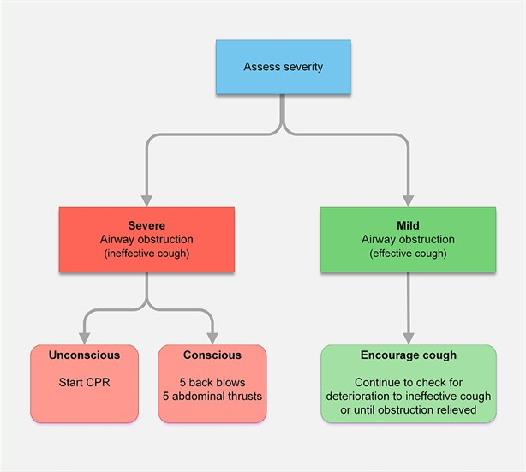

Should attempts at elevating the choking episode fail – the VMS clinician is expected to move to the cardiac arrest management emergency procedure (EOP2) applicable to their grade.

Should the choking algorithm be successful any patient that has had abdominal thrust should be conveyed to the nearest receiving A&E facility for further assessment

## Escalation

All non-paramedic staff are to call 999 or VMS Paramedic to lead. Consider clinical advice

# EOP4 Stroke Management – EOP Performance Indicator no1

VMS guidance is that any patient with a clinical impression of stroke or transient ischemic attack (TIA) will be conveyed to the nearest A&E department. The VMS clinician will be expected to undertake the following:

* Primary considerations for any ABC problem
* Perform a blood glucose reading
* Record an onset of symptoms time
* Perform a FAST test (symptoms to face, arms, speech, time)
* Emergency conveyance with a hospital pre-alert notification
* Be prepared for patient deterioration eg. Unconsciousness, seizure, cardio-respiratory arrest)

## Escalation

All non-paramedic staff are to call 999 or VMS Paramedic to lead with consideration to rapid conveyance to nearest definitive care.

# EOP5 Seizure Management

VMS guidance for the management of active seizure is to have effective airway management and if not present to seek paramedic level support for the administration of anti-convulsant medication. The VMS clinician will be expected to undertake the following:

* Primary considerations for any ABC problem
* Perform a blood glucose reading
* Perform a temperature check
* Apply safety precautions for the patient

Some patient are known to have seizure activity for various reason, should the patients seizure present in their usual fashion with their usual recovery, a consideration maybe given for discharge. The patient will be required to be in a place of safety with a responsible adult and worsening advice given.

## Escalation

All unexpected seizures or seizures outside of normal for patients should be conveyed to A&E. non paramedic staff are to default call to 999 or request VMS paramedic to enhance level of care

# EOP6 Severe allergic response & anaphylaxis management

VMS guidance will be in line with the key management principles provide by Resuscitation Council (UK). If not present a VMS clinician must request Paramedic level assistance and to apply effective airway management.

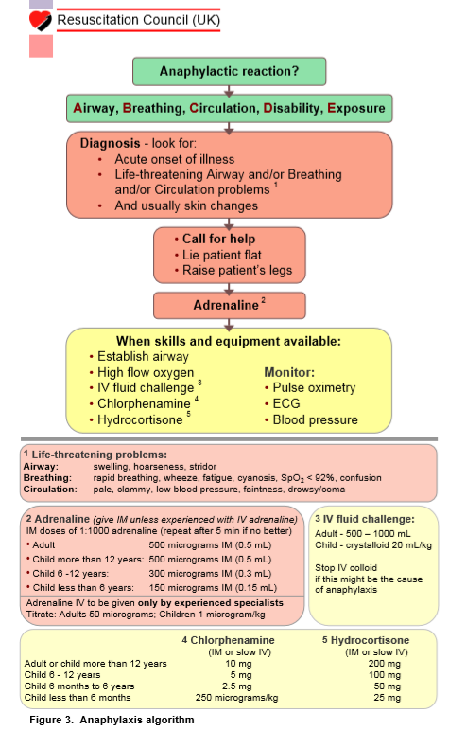

## Escalation

Any patient who has had a severe / anaphylaxis reaction must be conveyed to hospital as they maybe at risk of a bi-phasic response (secondary reaction). 999 consideration for pharmalogical intervention if not on site or if paramedical level care not available

# EOP7 Chest Pain Management

VMS guidance for the management of chest pain will be based on the key principles from JRCALC. Should a paramedic not be present one must be requested. The VMS clinicans are expected to:

* Primary considerations for any ABC problem
* Undertake 12 lead ECG
* Provide when paramedic available – Analgesia, Aspirin & Nitrates
* Emergency conveyance with hospital pre-alert notification

## Escalation

If confirmation of myocardial infarction the patient must be conveyed to the nearest Primary percutaneous coronary intervention (PPCI) with appropriate hospital pre-alert and medical director informed. If non paramedic consideration for 999 or VMS paramedic.

# EOP8 Scene Safety & Primary Survey

The VMS guidance in the area of scene safety and primary survey are as follows. A dynamic risk assessment of the scene must be undertaken regardless of clinical grade and the priority of safety comes first. The clinicians may use the Step 1-2-3 approach. If 1 patient approach as normal, if 2 patients approach with caution and if 3 patients do not approach and request Fire & Rescue Service.

The primary survey is a clinician’s way of identifying life threatening and life changing conditions. Each VMS clinician will use an ABCD with a consideration of catastrophic haemorrhage in the event of trauma.

Should a patient have a problem identified at any stage of the primary survey they are expected for example to sort A before moving on to B and B before moving on to C etc. In the event of a patient being primary survey positive consideration to time spent on scene is paramount and emergency conveyance to the nearest A&E department must commence at the earliest opportunity.

## Escalation

In the event of any incident which would place VMS staff, the patient or any other person in danger – the relevant emergency service must be called (999), VMS director informed and an incident report complete.

# EOP9 Defibrillation Management

VMS guidance in the area of defibrillation, link intrinsically with the safe use of defibrillation policy. The VMS clinician will be expected perform defibrillation as follows:

* ALS trained clinician in manual mode with shocks being delivered to any patient found to be in Ventricular Fibrillation (VF) or Ventricular Tachycardia Pulseless (VT)
* BLS trained clinician in automated mode with the AED instructions followed.
* Considerations for safety hazards such as water, oxygen, patient hair, transdermal patch, ICDs etc.
* One final safety check before delivery of shock by stating “clear at the Top, Middle & Bottom”
* It is expected that CPR will immediately recommence and the cardiac arrest algorithm cycle followed – until such time as a higher skill clinician says stop, ROSC or signs of life.
* Defibrillator pads may require changing after 5 or 6 shocks and this will be down to the judgement of the VMS staff member performing defibrillation.

## Escalation

* Ensure 999 has been called inline with VMS cardiac arrest EOP
* Should defibrillator 1 fail – all VMS resources have a 2nd defibrillator whether of a manual or automatic nature and the VMS clinician is to revert to the back-up device.
* Should PADs fail – all VMS resources have spares and must be replaced ASAP
* Should the be an incident where backup defibrillators fail and/or all PADs have been used – the VMS clinicians would be expected to perform CPR for as long as they can

# EOP10 Do Not Attempt Resuscitation (DNAR) & Advanced Directive of Refusal of Treatment (ADRT)

In all case where any DNAR document or any ADRT document is not present – default measure is to commence CPR until proven otherwise. Where these documents are presented to VMS staff. The most senior clinician must inspect them to confirm validity of documents.

The DNAR must meet the following points:

* Be dated
* Section 1 – one box must be circled
* Section 2 – Clinical problem must be stated to say why CPR would be inappropriate, unsuccessful or not in the patients best interests.
* Section 3 – Summary of communication with patient or legal attorney acting on their behalf
* Section 4 – Summary of communication with patients relatives and or friends.
* Section 5 – Names of any multidisciplinary teams contributing to DNAR
* Section 6 – Name of HCP recording this decision
* Section 7 – Reviewed & Endorsed by most senior HCP

On complete review of the above – all resuscitation attempts maybe ceased. Further details can be found in our DNAR Policy.

## Escalation

Should there be **any confusion** over a DNAR or any other directive – call to clinical advice via mobile or radio, control or a company director.

# EOP11 Palliative Care

Palliative care is care for the terminally ill and their families, especially that provided by an organisation in health care.

All VMS staff when dealing with a patient who is under palliative care should familiarise themselves with the patient’s care documentation, whilst taking into consideration their current wishes – in line with VMS Policies Consent, Capacity & DNAR.

Palliative care also can be referred to as “End of Life” care and the aim of this are to:

* improves quality of life
* gives relief from pain and other distressing symptoms
* supports life and keeping people as healthy as possible, regarding dying as a normal process
* doesn’t quicken or postpone death
* combines psychological and spiritual aspects of care
* offers a support system to help people live as actively as possible until death
* offers a support system to help the family cope during a person’s treatment and in bereavement
* uses a team approach to address the needs of the person who is ill and their families
* also applies to the earlier stages of illness, alongside other therapies that are aimed at prolonging life
* can take place in hospitals, hospices but also in people’s homes

## Escalation

Should VMS staff find themselves in any position of uncertainty – call through to a VMS director, Patient(s) own GP or 999 for ambulance service.

# EOP12 Prevention Management of Violence, Aggression & Restraint

Dealing with challenging patients can include challenging behaviour has a variety of causes, including illness. Consider whether a lack of resources is to blame. Seek ways to protect yourself, colleagues and other patients.

If required consult your operations manager or company director for advice.

## Why do patients become 'challenging'?

Patients, and sometimes their carers, become challenging, difficult, uncooperative or aggressive for a number of reasons:

* Being unwell or in pain.
* Alcohol/substance misuse.
* Fear, anxiety or distress.
* Communication or language difficulties.
* Unrealistic expectations.
* Previous poor experience.
* Frustration.
* Guilt that they didn't bring a sick relative in earlier.

## Their behaviour may take the form of:

* being demanding or controlling
* an unwillingness to listen/lack of cooperation
* verbal abuse or threats
* physical violence against people or property.

## Identifying the problem

### Is it the patient?

Always consider first whether the patient’s behaviour is caused by a medical condition. If so, treat the patient as far as possible without putting yourself or others at risk.

### Is it a lack of resources?

Long waiting times, lack of available appointments or beds, locums unfamiliar with the department, poor communication by staff, etc may all contribute to a patient’s deteriorating mood or behaviour.

### Is it the doctor?

Competing pressures on the doctor (time, resources, personal) may affect their communication style and potentially exacerbate the situation.

### Assessing the risk

Even if you are not in a position to determine the security policy at the trust or practice, you can seek ways to protect yourself, colleagues and other patients.

### ****Identify high-risk situations****

For example, Saturday night in the Emergency Department; when you have to deliver bad news, or when patients are kept waiting for a very long time. Consider which staff may be vulnerable if a patient becomes violent. Reception area staff or doctors working alone in a clinic may be at greater risk.

## Defusing a violent situation

* Dealing with an aggressive patient takes care, judgement and self-control.
* **Remain calm**, listen to what they are saying, ask open-ended questions.
* Reassure them and acknowledge their grievances.
* Provide them with an opportunity to explain what has angered them. Understanding the source of their frustration may help you find a solution.
* **Maintain eye contact**, but not prolonged.
* **Keep an adequate distance** from the patient, but keep away from corners. It is helpful if the furniture in your room is arranged in such a way that you can easily leave, but the patient doesn't feel trapped.
* If the patient has a weapon, ask them to put it down. Don't ask them to hand it over.
* Use the panic button or **call for help**.
* **Leave the room** and call security or the police.
* If possible, **move the patient to an area away from public view**.

## What can you do?

**Patients must not be denied necessary treatment** even though they may be aggressive or violent. Treatment must be based on clinical need, however demanding the patient.

Nevertheless, you should **assess and minimise the risks** to yourself, the patient and others. In some cases it may be reasonable and necessary to consider alternative arrangements for providing treatment.

If systems, policies or availability of resources are compromising patient care, you must **raise your concerns**.

It's advisable to **train staff in conflict resolution** and dealing with aggressive behaviour.

VMS do not operate a physical restraints policy – except in documented challenging situations that is for the safety of staff / members of the public. When doing so the only the most minimal interventions should occur and emergency contact with police and informing Company Director / reporting on incident reporting system must also occur.

## Escalation

In the event of any incident which would place VMS staff, the patient or any other person in danger – the relevant emergency service must be called (999), VMS director informed and an incident report complete.

# EOP13 Mental Health Risk Assessment, capacity & Conveyance

The assessment and management of the risk of a person with a mental illness causing harm to themselves or another is an extremely important part of mental health practice. A history of violence or risk to others is vitally important. A risk assessment should identify key factors that indicate a pattern or that risk is increasing.

* Test for capacity as per the VMS Mental Capacity Assessment form
* Consider supporting this with an Abbreviated Mental Test Score (AMT) and or a Sainsbury risk assessment tool score – Appendix 2
* Adopt a Your Safety First Approach and call police if required update VMS control / management – or if working for a 3rd party contact their control.
* VMS does not support physical restraint – except in extreme cases.
* Should deprivation of liberty (DOLS) be required – this is reportable under the VMS Reporting of Significant incidence and must be documented accordingly and accompanied with a MH capacity form
* Consider safeguarding or vulnerable referral as per VMS Safeguarding Policy & or 3rd party protocols – if unsure liaise with the applicable control room.

Conveyance of MH patients can sometimes be challenging calls for staff. It is expected that staff will follow mental capacity & consent policies, whilst ensuring the priority of their own safety. If after risk assessment the staff feels that there could be problems they are to inform when required:

* The Local Operations Manager
* Control Room
* Police

A pre-alert call to the receiving facility maybe required even if there is not a physical clinical reason for it but this should be emphasised when doing so.

VMS guidance is based on key principles of the VMS capacity form and VMS safeguarding policy. An registered VMS clinician must undertake a capacity assessment when in their professional opinion they consider this maybe in question as follows:

## The test of capacity

The Mental Capacity Act 2005 was enacted on 2nd April 2007. A key element is the test of capacity. This is essential in ensuring that people who lack capacity are protected.

There is a two-stage test of capacity in order to decide whether an individual has the capacity to make a particular decision, this test must be applied.

* Is there an impairment of, or disturbance in the functioning of a person's mind or brain? if so
* Is the impairment or disturbance sufficient that the person lacks the capacity to make a particular decision?

It is essential that the decision makers uphold the principles of 'equal consideration'. The Act is clear that there should not be assumptions made about an individual's lack of capacity based on either their age or appearance or condition.

If the first stage of the test of capacity is met, the second test requires the individual to show that the impairment or disturbance brain or mind prevents them from being able to make the decision in question at that time.

## The Functional Test

This is a functional test focusing on how the decision is made, rather than the outcome or the consequence of the decision.

* To understand the information relevant to the decision,
* To retain that information,
* To weigh that information as a part of the process of making a decision,
* To communicate his/her decision (whether by talking, using sign language or any other means).

This test must be complete and recorded; the documentation must demonstrate the above process.

Should there be a requirement to deprive a patient of their liberty the following 5 statutory Principles from the Mental Capacity Act must be actioned

The Act is underpinned by five principles, which are contained within the act and explained in the Mental Capacity Act code of practice:

* a presumption of capacity - every adult has the right to make his or her own decisions and must be assumed to have capacity to do so unless it is proved otherwise
* the right for individuals to be supported to make their own decisions - people must be given all appropriate help before anyone concludes that they cannot make their own decisions
* that individuals must retain the right to make what might be seen as eccentric or unwise decisions
* best interests - anything done for or on behalf of people without capacity must be in their best interests
* least restrictive intervention - anything done for or on behalf of people without capacity should be an option that is less restrictive of their basic - as long as it is still in their best interests

Additionally, the VMS clinician is expected to inform the Clinical director so that VMS can follow the reporting of significant incidents policy and inform the relevant authorities including the CQC

## Escalation

Should **escalation** be required during any MH interaction immediate requests for police, management and informing control must all take place when safe to do so. On completion of such event an incident report must be completed.

# EOP14 Management of potential crime scene and or victims of crime

Dealing with patients that have been victims of crime can be emotionally and physically draining. VMS staff can seek advised from the operations manager and or company director as per our clinical advice protocols.

Where possible VMS staffs are to protect scenes of crime and victims of crime to preserve evidence – however, this is not at the expense of life threatening and or life changing injuries or illness.

Victims could included sexual assault, physical assault, abuse or any other criminal action that causes injury or illness. VMS staff a reminded to stay in scope of clinical level of practice and to consider the following:

* Treat priority symptoms
* Preserve evidence where possible and when possible avoid cross contamination
* If not already requested – call police or ask the control staff to do so
* Consider data protection and Caldicott principles on sharing information
* Safeguarding referral if required
* Consider VMS Health & Wellbeing policy for you own welfare

# EOP15 Management of Clinical Handover

Clinical handover is defined as: A **Handover** occurs between the health care professional that holds responsibility for care and another healthcare professional who will be assuming responsibility for the care of the patient.

This could be between VMS staff, VMS staff & Hospital staff, VMS staff & Ambulance trust staff, VMS staff & other pathway HCPs such as GPs, Dentists, Social Services, 111 etc

The following principles must apply:

* Only share the minimal required information
* Where appropriate – consent must be obtained. Except when working benevolently in the best interests of the patient. Or from someone who holds permission for the patient such as a NOK or a holder of advance documentation.
* Pertinent information that is significant to patient care such as, primary complaint, history, interventions, medications, allergies etc are all examples of this
* A signature must be received and a time stamp given on completion of clinical handover
* The crew should aim to ready to clear from call within 15 minutes of clinical handover – however, if this is likely to be longer as a result of safeguarding, falls, or any other type of referral the crew is to inform the control room
* Other reasons for prolonged delay may include but not limited to: staff wellbeing, IPC, equipment & vehicle faults etc.

## Escalation

It is not expected to require escalation in this EOP – but should the VMS staffs have any issues surrounding the clinical handover of patient – they can provide an incident report on the VMS portal or hardcopy system.

# EOP16 Management of the absconding patient

The principle of any patient interaction received a patient record form still applies to an absconding patient. There will be incidences where staff may have all, part or none of the patient's details. However, this should be recorded with the appropriate timings on a PRF along with comments of why and what happened.

In certain circumstances you may have to report for safeguarding or police in cases where you feel the patient and or public may be deemed at risk. Advice can be sort from control or VMS management.

It may also be required that the crew adopt a search and / or follow process in order to get a complete picture of call in question.

## Escalation

If the VMS staff have concerns about safety or welfare of an absconding patient – a call through to police or implementation of the VMS safeguarding policy should be considered

# EOP17 Management of obstetric emergencies

The management of obstetric emergencies should be in-line with the staff members level of clinical scope. This can be found within the clinical governance policy and adapted colour scope matrix.

Obstetric emergencies can be challenging for the most experienced professionals but for ambulance staff this can also be a very scary situation. Backup / **escalation** requests must be ensured at every occasion and these can include higher skill sets to scene, rendezvousing with higher skills set en-route to the receiving facilities, a midwife or rapid transportation (if qualified) & pre-alert.

Guidance can be sort from JRCALC and other reputable resources such as UK resus council and NICE or clinical advice as per the operational plan. This maybe a VMS doctor, paramedic or a 3rd part providers own clinical advice system.

Significant information:

* There is only one patient until such time that a mother has given birth and the cord has been cut.
* Priority with be with the mother until such time as above.
* When there are multiple patients – staff are to prioritise using the JRCALC triage method.

## Escalation

An escalation call to 999 or hospital on-call midwifery must be completed at every incident – depending on the capacity of which VMS are working.

# Review

It is expected that this policy will be one of the most reviewed VMS policies and that this will be added to the QA monthly agenda in due course but will remain subject to our annual review process.

To be reviewed Bi-annually or sooner if required as per clinical governance

# Appendix 1 - Emergency Arrangements

Where the company does not have a company director in attendance - A Company Director will provide an on-call / out of hours emergency advice line for all staff on a 24/7 basis. These details are as below and given during new employee induction.

* Clinical Director for clinical emergency advice 01473 557655 or 07984 069644
* Managing Director for corporate / logistical advice 01473 557616 or 07825 760919
* Operations manager 07592 853847
* 3rd party providers such as EEAST, E-Zec etc as per operational instruction

# Appendix 2 - Abbreviated Mental Test Score (AMTS)

The abbreviated mental test score (AMTS) was introduced by Hodkinson in 1972 to rapidly assess elderly patients for the possibility of dementia The following questions are put to the patient. Each question correctly answered scores one point:

1. What is your age?
2. What is the time to the nearest hour?
3. Give the patient an address, and ask him or her to repeat it at the end of the test e.g. 42 West Street
4. What is the year?
5. What is the name of the hospital or number of the residence where the patient is situated?
6. Can the patient recognize two persons (the doctor, nurse, home help, etc.)?
7. What is your date of birth? (day and month sufficient)
8. In what year did World War 1 begin?
9. Name the present monarch/prime minister/president.
10. Count backwards from 20 down to 1.

A score of 6 or less suggests delirium or dementia, although further tests are necessary to confirm the diagnosis.

